

The Hashemite University



|  |  |  |
| --- | --- | --- |
| الاسم | الرقم الجامعي | التخصص |
| عبد الهادي فوزي حسين | 1441149 | CS |
| حمزة وليد الخالدي | 1332665 | CS |
| زيد خالد المصري | 1331229 | CS |
| كامل صالح كامل ابو خالد | 1331325 | SW |
| محمد طلال ابو عبيد | 1342341 | CIS |

Credits

Life is a music that everyone hears it differently therefore everybody sing their own song.  
Abdelhadi Hussein ®  
Dec -2nd-16

**Last edited Dec – 18th - 2016**

**Supervisor:**   
Dr.Emad Abdullah

Also available in power point

TABLE OF CONTENTS

**1. Introduction**

1.1 Problem Statement   
 1.2 Objectives.

**2. Requirements**

2.1 Functional and Non-Functional

2.2 Use Case

2.3 Scenarios

2.4 Data Gathering

**3. Analysis (Dynamic Model)**

3.1 Sequence Diagram

3.2 Activity Diagram

3.3 Data Flow Diagram

**4. Preliminary Design**

4.1 Database

4.2 GUI  
  
**\* Solutions statement**

1. **Introduction:**

We all have difficulties getting to classes on time, we all have issues writing notes.  
Sometimes we can’t get to the course material on time, sometimes you’re just not focused enough during class!  
With “YouHU” an app that will allow you to watch and get all the help you need with your classes ONLINE using your android device or desktop.  
It will allow lecturers to upload their actual (interactive) classes online, giving students the chance to review these classes and communicate with lecturers, making education a better experience for both students and instructors.

In the recent years education has grown into an essential need and human mankind always searched for evolution to make their lives easier, education quality “as an essential need” has to be enhanced in order to live in prosperity and create extraordinary achievements.

* Many students who have problems in reaching lectures for several reasons, some examples:   
  Students whom living far away from The University campus, disabled students who are suffering in reaching The University classes, bad weather is also a problem when reaching The University and it might put The University members in danger.
* Some students have problems in participating directly in lectures; for example students who have learning disabilities.
* Not taking full benefit out of the office hours because students use it to illustrate the course material and lectures mostly, instead of discussing their questions and thoughts about the course. * Wasting the instructor time instead of taking full benefit of it*
* Sometimes students are not focused enough or distracted during lectures.

1.1 Problem Statement:

1. Access to lectures online.
2. Access to course material.
3. Rate lectures.
4. Comment on lectures videos and communicate with lecturer.
5. Create section for IT-Plus(as an example) lectures and discussion.
6. Add calendar for lecture times, exams, college events and holydays + (Prayer times if requested).
7. Add student plan.
8. Give students notifications about weather, and academic warnings.
9. Display detailed university campus.

10.University news.

11.Exams results.

12.Online Conferences for Projects.

1.2 Objectives:

2.1.1Functional:

This website, android app provides a login page where you can view university news, specialty plan, uni-campus.  
The ability see live videos of (lecture of teacher) and save videos to see later also site to download documents in course material section.

The ability to open discussions with the lecturer, Group admin and other class mates.

**2.1 Functional &  
 non-Functional**

**2.1 Functional and non-Functional**

2.2 Use Case

2.3 Scenarios

2.4 Data Gathering

**2. Requirements**

2.1.2: Non-Functional:

**Availability**

This system is customers can use a 24-hour application materials at any time and in any place but now to discuss the request in specific materials are certain times by the competent authorities one of the branches.

**Security**

Each client has a special user name and password for approval cannot be accessed by someone else and modifies data or user requests on the website.

**Usability**

Ease of use of the system without prior training (all data are good base for renovation when introduction any new data) shows the system in every job-site part.

**Interactivity**

The system allows for a worker and specialists in user interaction service because there are always the amendments to articles and other things.

**Immediacy**

This system is online and updated quickly

**Flexibility**

Between this system which follows the positive working conditions in the applications materials and easy handling with the system to send and receive data

**Efficiency**

Because the system may become all the process in a shorter time than it was manual, and should be high-speed system of data access.

For example, the system must provide any information in the query part of speed

**Portability**

The new system goals have been achieved because the site/android-app easily handles 24 hours for all clients and officials. And it can operate in any environment.

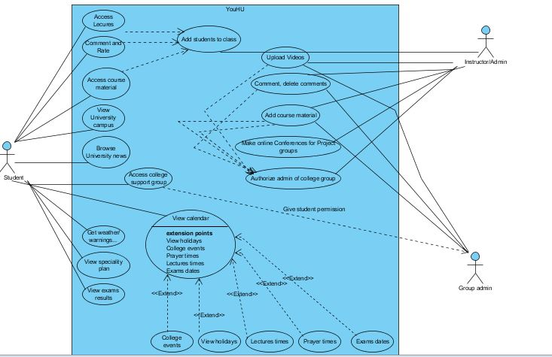

A) YouHU System

A) YouHU System  
B) Instructor  
C) Group Admin  
D) Student

**2.2 Use Cases**

B) Instructor

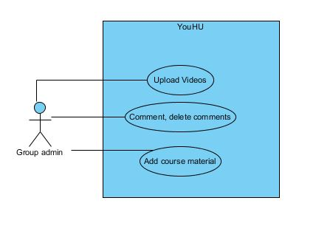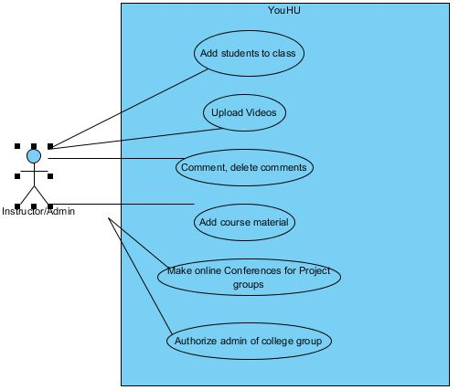

C) Group Admin

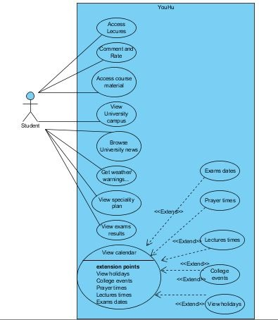

D) Student

2.3 Scenarios

|  |  |
| --- | --- |
| **Use case name** | **Access lectures** |
| Actors | Student |
| Uses | Add students to class |
| Extends | Nil. |
| Pre-conditions | Instructor added the student to the class |
| Basics Course/Main  Scenario | 1.Student register into the class 2.instuctor adds the student to the class 3.Student can view the course video lectures |
| **Use case name** | **Comment and rate** |
| Actors | Student |
| Uses | Add students to class |
| Extends | Nil. |
| Pre-conditions | Instructor added the student to the class |
| Basics Course/Main  Scenario | 1.Student register into the class 2.instuctor adds the student to the class 3.Student can discuss, comment and rate lectures |

|  |  |
| --- | --- |
| **Use case name** | **Access course material** |
| Actors | Student |
| Uses | Add students to class |
| Extends | Nil. |
| Pre-conditions | Instructor added the student to the class |
| Basics Course/Main  Scenario | 1.Student register into the class 2.instuctor adds the student to the class 3.Student can access the course material |
| **Use case name** | **Access collage support group** |
| Actors | Student, Group Admin |
| Uses | Group Admin |
| Extends | Nil. |
| Pre-conditions | Group Admin adds the student to the Support Group |
| Basics Course/Main  Scenario | 1.After student been accepted in his specialty 2.Student send member ship request to the collage support group 2.Colloage support group admin accept the student to the collage support group |

|  |  |
| --- | --- |
| **Use case name** | **View calendar** |
| Actors | Student, Instructor |
| Uses | Nil. |
| Extends | View holidays, Collage events, Prayer times, Lecture times, Exams dates |
| Pre-conditions | Nil. |
| Basics Course/Main  Scenario | Anyone can see events on the YouHU |
| **Use case name** | **Add students to class** |
| Actors | Instructor |
| Uses | Nil. |
| Extends | Nil. |
| Pre-conditions | Instructor is registered as the course/class supervisor |
| Basics Course/Main  Scenario | Instructor adds students who registered the course to the class |

|  |  |
| --- | --- |
| **Use case name** | **Upload videos, comment, delete comments, Add course material** |
| Actors | Instructor, Group Admin |
| Uses | Nil. |
| Extends | Nil. |
| Pre-conditions | Authorize admin of collage group (for group admin user) |
| Basics Course/Main  Scenario | 1) Instructor gives the authority to admin of collage group 2) both actors can Upload videos, comment, delete comments, Add course material |
| **Use case name** | **Make online conferences for project groups** |
| Actors | Instructor |
| Uses | Nil. |
| Extends | Nil. |
| Pre-conditions | Students must be registered in Project (1 or 2) and supervised by the same instructor. |
| Basics Course/Main  Scenario | 1) Instructor add the date/ time of the conference 2)Student get notified  3)Students can join the conference when its time |

2.4 Data Gathering

The following questions were used during a series of interviews with undergraduate students at (Hashemite University), The study was undertaken as part of planning:

Questions for Interview Project Focused on Perception of use website and android app”YouHU”:

1. Something you like about the website and mobile application?
2. Your favorite thing about the website and mobile application?
3. Changes you’d apply to either website or android app?
4. Features you’d like adding?
5. Things that “work” as expected in the website and mobile application?
6. Things that “don’t work” as expected in the website and mobile application?
7. Features that you like in the website?
8. What kind of communication devices do you use?
9. Most tools you use in the website?
10. Your favorite part of website and mobile application?
11. How you keep track of your school work and other activities?
12. Things that causing a problem in the website and mobile application?
13. What technology do you use for school study?
14. How do you take notes in class?
15. Do you have a laptop? Do you bring it to the University?
16. How do you communicate with website and mobile application?
17. Would you like to use this website “YouHU” again?

**\*Service Preferences (Questions):**

When you use the website how did you find out the performance of the service?

When you use the website, how does this website or mobile app usually interact with you?

Tell me about recent good services you’ve had in the website?

Let’s say you were working in the website or mobile app and encountered a problem — it might be any sort of problem(technical, printing, getting information, communication problem , some kind download documents failure ) — what would you do?

*This study was based on random sample of students who use the website”YOUHU” and the mobile application.

**3. Analysis (Dynamic Model):**

**3.3 Data Flow Diagram**

This is an abstraction for the basic process done by the software in contact with the user. And it specifies the simplicity and the ease of use for this system

3.1 Sequence Diagram

**3.2 Activity Diagram**

**3.1 Sequence Diagram**

A) Instructor Admin

B) Student

C) Group Admin

**A) Instructor Admin**

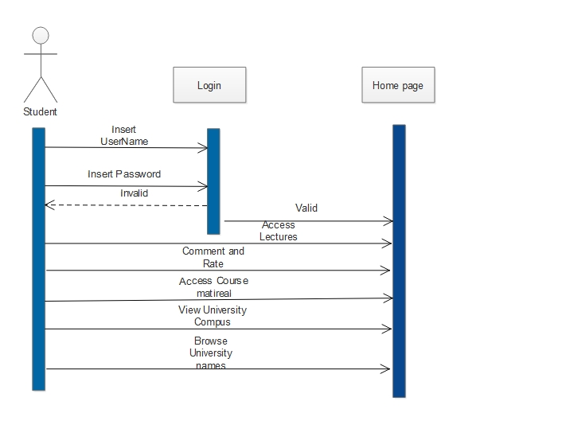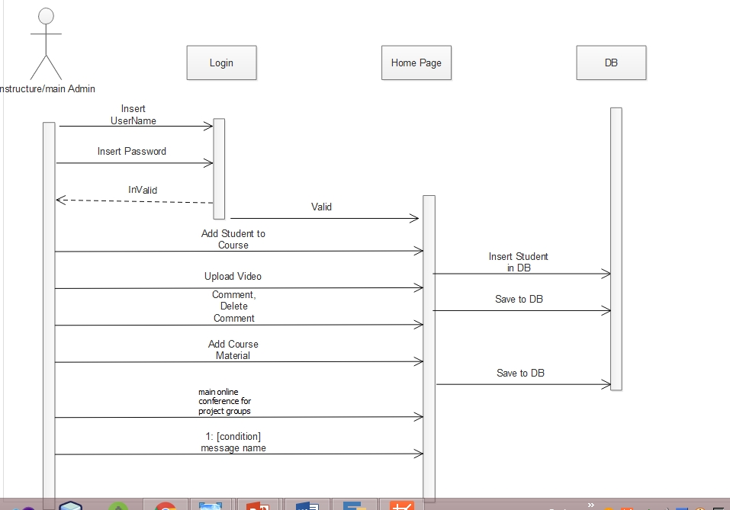

**B) Student**

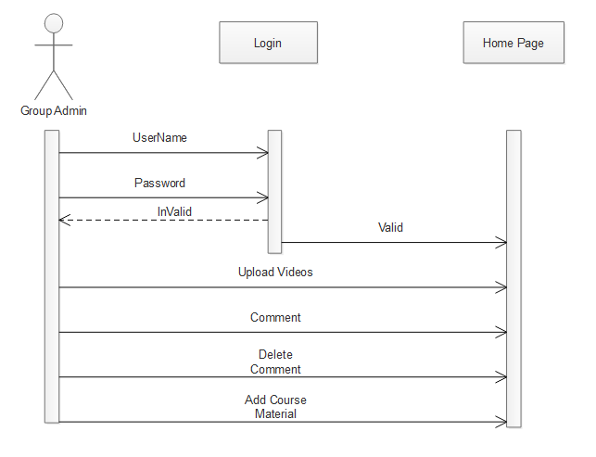

**C) Group Admin**

Activity diagram is another important diagram in UML to describe dynamic aspects of the system. Activity diagram is basically a flow chart to represent the flow form one activity to another activity. The activity can be described as an operation of the system

3.2 Activity Diagram:

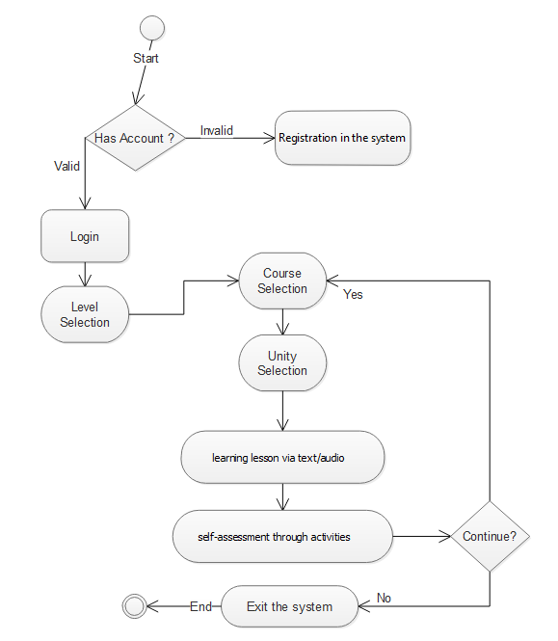

**3.3 Data Flow Diagram:**

A data flow diagram (DFD) is a graphical representation of the "flow" of data through an information system, modeling its process aspects. A DFD is often used as a preliminary step to create an overview of the system, which can later be elaborated.

**A) Context Diagram**

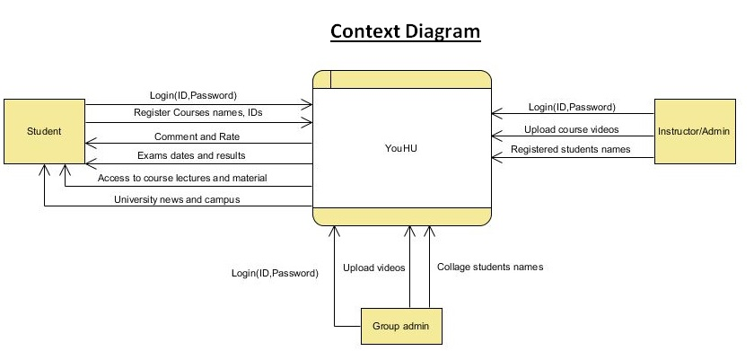

This Context Diagram consists of 3 entities   
1) Student. 2) Instructor. 3) Group Admin.  
After student logs-into the system and register courses he can view the course material after its been uploaded by the Instructor and Group admin, also he/she can open discussions with the admins using comments.   
All the entities can view the university campus, news.  
Student can view his previous or current exams results after logging-in.

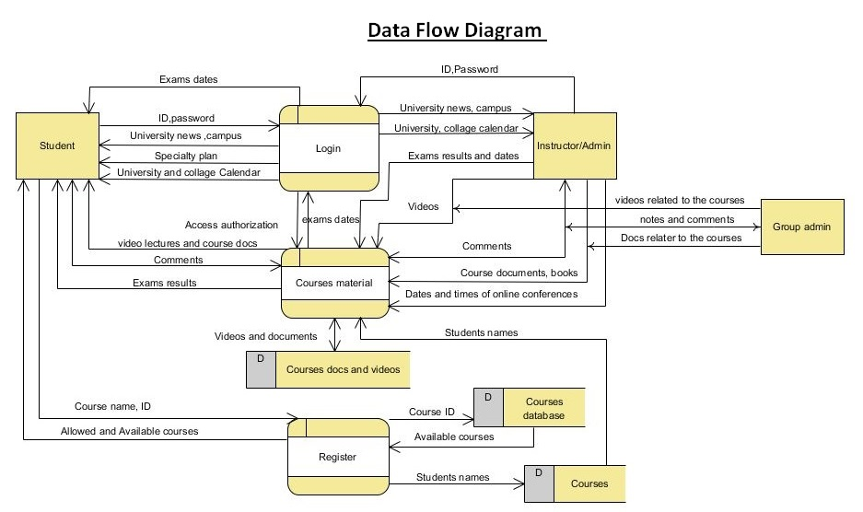

This DFD was decomposed from YouHU System/process it has 3 process   
1) Login. 2) Courses material. 3) Register.   
**Login** process allow users to view the university campus, news, events and calendar before they sign-in and it authorizes the users to proceed to the other process.  
**Courses** material process allows Student to view course materials, exams results, open discussions using comments and it also pass student names from **Courses Database** to the Instructor so he/she may add students to his/her class. It also allows Admins to upload the course material to the **Courses docs and videos Database.  
Register** process allows Students to add/view courses and sends their names to **Courses** DB.

**B) Data Flow Diagram**

**4. Preliminary Design**

**4.1 Database**

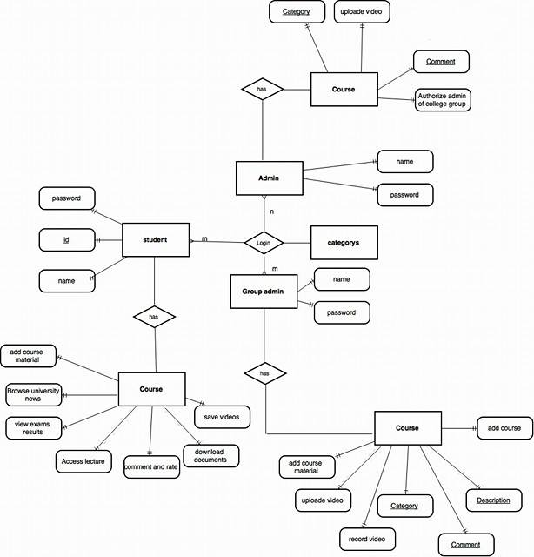

**ER diagram:**

This diagram consists of three majorities:   
1.student 2.admin 3.group admin  
Student has password and name to login, and he’s also able to save videos, download documents, comments and other attributes mentioned in the diagram.  
Admin has password and name to login and he’s able to upload videos, comments and to authorize admin of college group.  
Group admin has name and password to login and he’s able to add course material, upload videos and other attributes mentioned in the diagram.

**4.2 Graphical User Interface:**

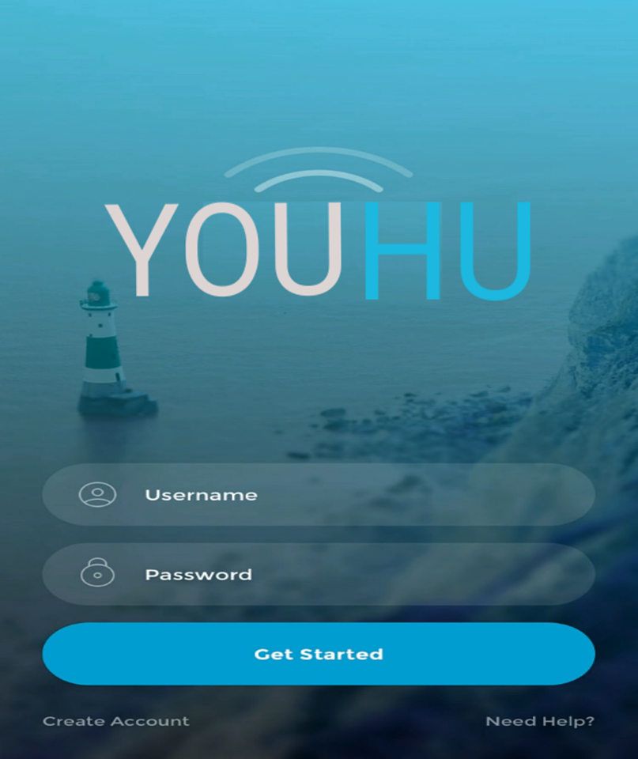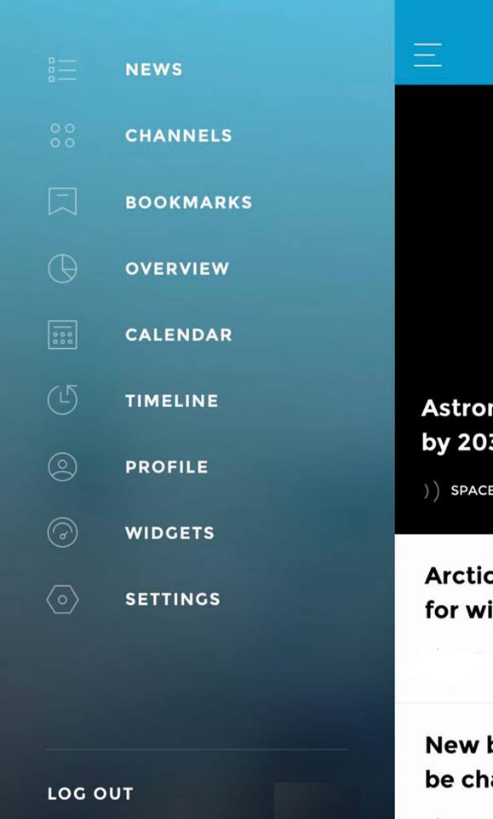

User Menu Interface

Login Interface

* To take full benefit out of the office hours, students can review the course material online, see discussions in the comments and then if they’re facing any problem or having some really hard questions they can refer to the instructor in the office hours as well as the instructor can reply to comments during the office hours and voluntarily after.
* Students who have problems participating during classes or have learning disabilities can view lectures as many times as they wish to and discuss it with the Admins.
* During heavy weather conditions, students and Instructors/lecturers don’t have to come to the University or risk their lives trying to, instead they are being notified by YouHU about the weather condition. Instructors can just record lectures from their homes (if he/she can) and students will view it from their homes after its been uploaded.

* Solutions statement: